

**Woven Together: A System Guide for Stephanie’s Creations**

**Prepared for:  
Dr. Andy Bowman  
MIS 4173 – 601  
East Carolina University  
Spring 2025**

**Prepared by:  
Hannah Clark  
Heather Siler  
Lauren Geis**

Table of Contents

I. 3

Executive Summary with Narrative and Conclusions 3

Company Background & Current Environment 3

Problem Analysis (BPA, BPI, BPR) 3

Proposed System Objectives & Constraints 4

Expected Benefits 5

Context Diagram 5

II. 6

Executive Summary with Narrative and Conclusions 6

Use Case Diagram 6

Supplement Specifications (Non-Functional) 7

III. 8

Executive Summary with Narrative and Conclusions 8

Complete Data Flow Diagram Package 8

Hardware and Software Specification 8

Navigation Diagram 8

Entity Relationship Diagrams 8

Program Plan showing logic and I/Os (IPO Chart with each program listed) 8

Standard Naming Conventions 8

IV. 8

Executive Summary with Narrative and Conclusions 8

Test Plans 8

Training Manual and/or Reference/Procedure Manual 8

Technical Manual 8

V. 8

Executive Summary with Narrative and Conclusions 8

Migration Plan (Business, Technical, People Readiness) 8

Personal Project Assessment (by each member) 8

Lessons Learned during the project (by group) 8

Explanation of challenges, problems and discoveries 8

All Burndown Charts, All Backlogs, All Meeting Logs 8

Any other supporting documentation 8

# I.

## Executive Summary with Narrative and Conclusions

This section provides an overview of Stephanie’s Creations—a homegrown crochet business that began as a hobby during the COVID-19 pandemic and evolved into a passion-driven small business. Section 1 examines the current manual processes and identifies opportunities for improvement through problem analysis, proposed system objectives, constraints, and expected benefits.  
The new system will introduce inventory tracking, sales management, customer data storage, and e-commerce integration, focusing on ease of use, affordability, and scalability. Expected benefits include increased efficiency, improved organization, and enhanced customer service, enabling Stephanie to expand her business and continue her philanthropic efforts.

## Company Background & Current Environment Stephanie began crocheting in 2020 as a hobby during the COVID-19 pandemic. After a prolonged battle with Lyme disease, she found comfort in crafting handmade baby blankets, scarves, and hats. What started as a therapeutic pastime soon became a passion, inspiring her to donate warm clothing to local children in need.

Initially, she planned to launch an Etsy shop, but progress was delayed due to hip replacement surgery. Now fully recovered, Stephanie is eager to establish an online business to share her creations with a wider audience while continuing her philanthropic efforts.

Currently, no formal information system is in place. Order management, inventory tracking, and sales are handled manually, with transactions processed through mobile payment apps. Without a centralized system for managing customer data or automating fulfillment logistics, scalability remains a challenge as the business expands.

## Problem Analysis (BPA, BPI, BPR)

Given Stephanie’s current manual workflow, our team recommends a Business Process Improvement (BPI) approach rather than a full Business Process Reengineering (BPR) overhaul. Since she already has an informal system in place and plans to expand to an online platform, refining her existing operations is more practical than a complete restructuring.

While Business Process Automation (BPA) may be considered in the future to streamline tasks such as customer engagement and predictive inventory tracking, our immediate focus is on enhancing system usability and optimizing core processes for efficiency.

## Proposed System Objectives & Constraints

|  |  |
| --- | --- |
| System Objectives | |
| User-Friendly Interface | The system should be intuitive and easy to navigate, requiring minimal technical knowledge. |
| Inventory Management | Enable efficient tracking of available stock, materials, and finished products. |
| Sales Tracking | Provide tools for recording transactions, monitoring sales trends, and generating reports. |
| Customer Management | Maintain customer details, including order history, preferences, and shipping information, to enhance service. |
| E-commerce Integration | Support seamless integration with online marketplaces to streamline product listings and order processing. |
| Cost-Effective Solution | Minimize recurring costs while maintaining essential functionality. |
| Security & Compliance | Ensure secure storage of customer payment details and personal information in compliance with industry standards. |

|  |  |
| --- | --- |
| System Constraints | |
| Budget Limitations | The system must operate within financial constraints, including hosting, payment processing, and potential subscription fees. |
| Accessibility Considerations | Design must accommodate various visual needs, ensuring readability and ease of use. |
| Limited Technical Expertise | The system should require minimal maintenance and technical knowledge. |
| Scalability | While initially designed for small-scale operations, the system should allow for future expansion. |
| Platform Compatibility | The system should integrate seamlessly with potential websites or e-commerce platforms. |

## Expected Benefits

**Improved Efficiency**

Automating sales, inventory tracking, and order fulfillment will significantly reduce the time and effort required for manual data entry and management. By minimizing repetitive tasks, Stephanie can focus more on creating new products and engaging with customers.

**Scalability**

Implementing a structured system will allow the business to grow without overwhelming manual processes. As demand increases, the system will support additional orders, new product listings, and expanded inventory without requiring extensive operational changes.

**Enhanced Organization**

A centralized platform for order tracking, inventory management, and customer interactions will create a more streamlined and structured workflow. This will reduce errors, prevent stock discrepancies, and ensure that Stephanie always has a clear overview of her business operations.

**Better Customer Service**

By automating fulfillment processes and maintaining accurate records of customer orders and preferences, Stephanie can ensure timely and error-free deliveries. Improved tracking capabilities will also help her provide quick responses to customer inquiries, enhancing overall satisfaction and loyalty.

## Context Diagram

# II.

## Executive Summary with Narrative and Conclusions

In developing Stephanie’s crocheting business website, we have given a lot of attention to making sure that the user’s experience is as smooth and secure as possible. This section describes the systems non-functional requirements and uses a use case diagram to show how the system interacts.

The use case diagram shows key interactions which include product management, inventory tracking, and payment processing. The non-functional requirements include usability, performance, security, portability, and legal aspects. The system will be user-friendly and easy to navigate. Measures of performance are fast response times and high availability, and security features include data encryption.

## Use Case Diagram

## Context Diagram

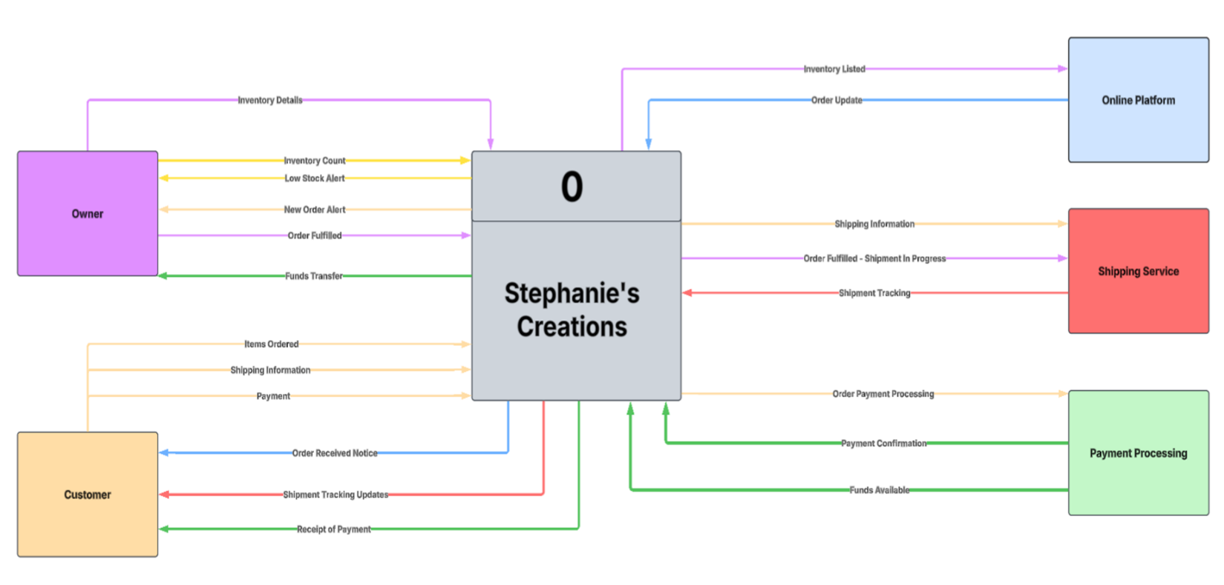

## Supplement Specifications (Non-Functional)

**Usability**

* **Ease of Use:** The system should be designed so that users can navigate and operate it intuitively without confusion. All key functions must be accessible within the rule of three.
* **Accessibility:** It must be available to a wide range of users, including those with disabilities, ensuring compliance with accessibility standards.
* **Learnability:** New users should be able to quickly understand and become proficient with the system, reducing the learning curve.

**Performance**

* **Response Time:** The system should provide prompt feedback on user actions, ensuring a smooth and efficient interaction.
* **Scalability:** It must handle growing amounts of work or increasing numbers of users without compromising performance.
* **Availability:** The system should be consistently operational and accessible when needed, minimizing downtime.
* **Data Capacity:** It should be capable of managing and processing large volumes of data efficiently.

**Security**

* **Data Encryption:** Sensitive information must be protected using encryption to prevent unauthorized access or breaches.
* **Access Control:** The system should enforce strict permissions, ensuring users can only access data and functions that are relevant to their roles.
* **Data Backup and Recovery:** Regular backups and robust recovery processes should be in place to safeguard data integrity in case of failures or data loss.

**Portability**

* **Platform Compatibility:** The system should operate smoothly across various operating systems and environments.
* **Integration Options:** It must support easy integration with other systems or software, enabling seamless data exchange and interoperability.

**Legal and Regulatory**

* **Data Privacy:** The system must comply with relevant data privacy laws and regulations, ensuring that users’ personal information is handled responsibly and securely.

# III.

## Executive Summary with Narrative and Conclusions

## Complete Data Flow Diagram Package

## Hardware and Software Specification

## Navigation Diagram

## Entity Relationship Diagrams

## Program Plan showing logic and I/Os (IPO Chart with each program listed)

## Standard Naming Conventions

# IV.

## Executive Summary with Narrative and Conclusions

## Test Plans

## Training Manual and/or Reference/Procedure Manual

## Technical Manual

# V.

## Executive Summary with Narrative and Conclusions

## Migration Plan (Business, Technical, People Readiness)

## Personal Project Assessment (by each member)

## Lessons Learned during the project (by group)

## Explanation of challenges, problems and discoveries

## All Burndown Charts, All Backlogs, All Meeting Logs

## Any other supporting documentation